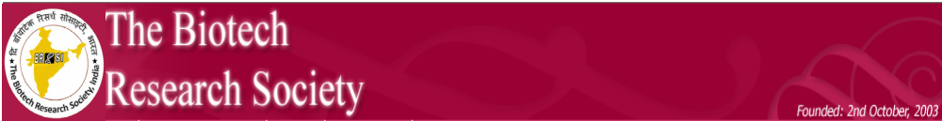
A Decade of Journey
2003-2013

BRSI-A Decade of Journey
(2003-2013) Celebrations

A general assembly of the members of the Society was held at 6.00 pm on 24th November 2013 at Hotel Le Meridien, Pune to celebrate the occasion of ten years of establishment of the Society. About 125 Life Members of the Society and the invitees of ICABB-2013 attended this. Padmasree Prof Asis Datta was the Chief Guest of the function. The occasion was blessed by the presence of Prof P Gunasekaran, BRSI President and Vice-Chancellor, Tiruvalluvar University, Vellore; Prof KB Powar, Chancellor, Dr DY Patil Vidyapeeth, Pune; Dr PN Razdan, Vice-Chancellor, Dr DY Patil Vidyapeeth, Pune; Prof. Ashok Pandey, Deputy Director, CSIR-NIIST, Trivandrum & Founder President, BRSI Prof R Banerjee, General Secretary, BRSI and Dr MB Khetmalas, Convener of ICABB-2013 on the dais. In his opening remarks, Prof Gunasekaran welcomed the invitees and the members of Society. He mentioned the aim and scope of Society and hoped that the Society will continue to thrive best to fulfil its goal. He mentioned that the BRSI has several unique features, which included its fast growing membership and six international MoU Society has with different international organizations. Prof Powar, Prof Rajdan and Dr Khetmalas felicitated the occasion.

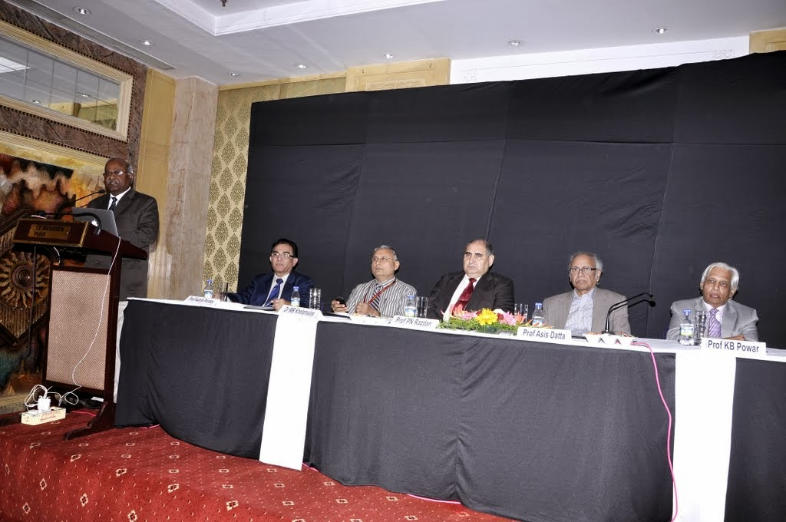

To commemorate the decennial celebrations of the Society and the occasion, a book was prepared by the Central Office of the Society, which provided the history and development of the Society taken place during the ten years of its growth. The book was compiled and edited by Dr P Binod. This was released by the Chief Guest of the function, Prof Asis Datta.

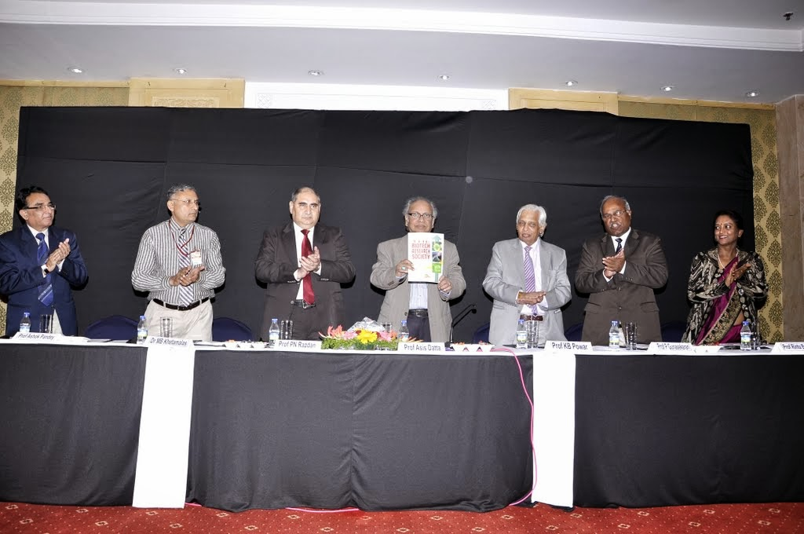.

Then gathering was informed about the quarterly news letter of the Society which has been published uninterruptedly since the established of the Society beginning January 2004. So far, ten volumes of the News letter, comprising 40 issues of have been published. These were compiled together and published as an archive. This book was released by Prof Powar.

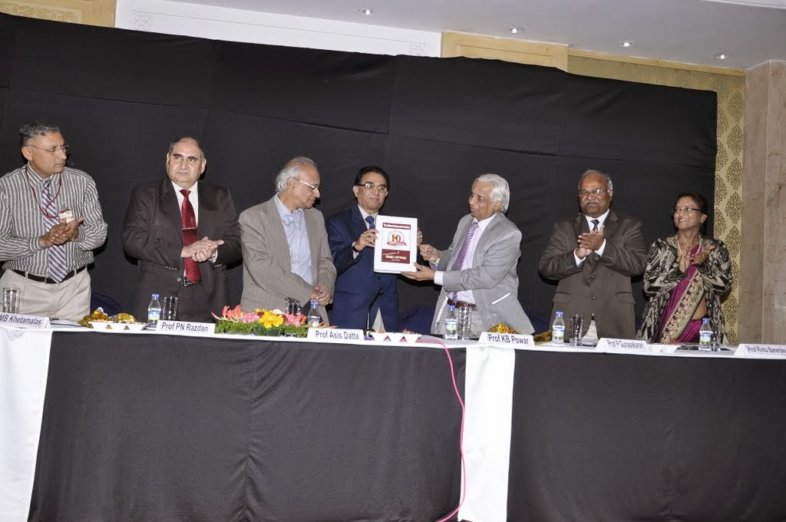

This was followed by a presentation by Prof Ashok Pandey about the history and development of the Society. Prof Pandey traced the moments in early 2003 when the idea to establish such a society was conceived and then the Society was born on 2nd October 2003 with a Board of Trustees comprising 23 members from academia and industry, representing the premier institutions in the country with geographical balance. He gave a chronological detail about the growth of the Society in terms of membership and finance and detailed when the Units were established. He presented the details of institutional members along with the Units. He also gave the information about the MoU BRSI has with the international organization. Prof Pandey also gave the details of BRSI awards given annually to its members (which included Life-Time Achievement award, Woman Scientist award, Young Scientist award and Industrial medal award) and added that the organizers of 2nd, 6th and 7th Conventions have provided financial contributions to institute memorial awards named as Anna University-Centre for Biotechnology (AU-CBT) Excellence award (two), Malaviya Memorial award (two) and Madurai-Kamaraj University-School of Biological Sciences (MKU-SBS) Genomics award (one), respectively to be given annually. The financial contributions made by the conveners of the 3rd and 4th Conventions were also remembers.

Thereafter, the people who mentored the Society and shouldered the responsibility to organize the conventions of the Society were remembered and honoured. These included:

Prof SB Chincholkar, I Convention (2004), North Maharashtra University, Jalgaon

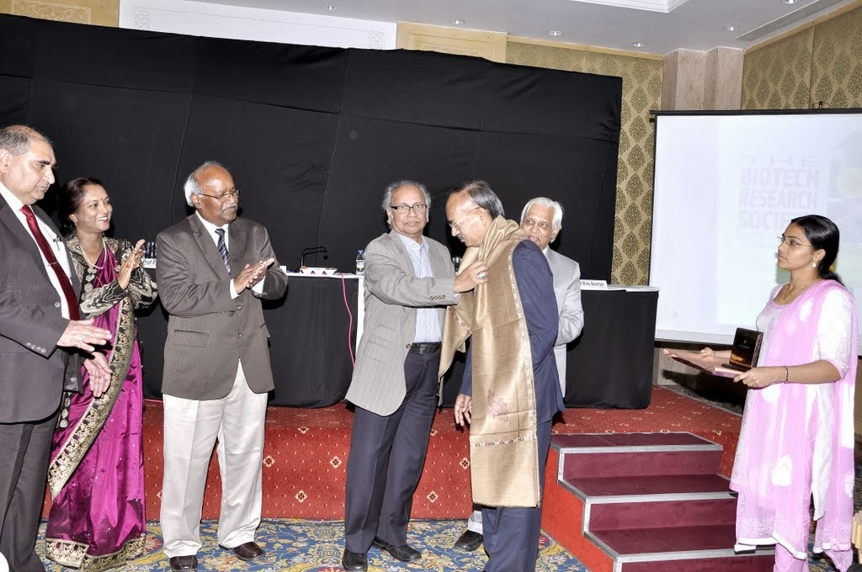

Prof K Sankaran & Prof P Kaliraj, II Convention (2005), Anna University, Chennai

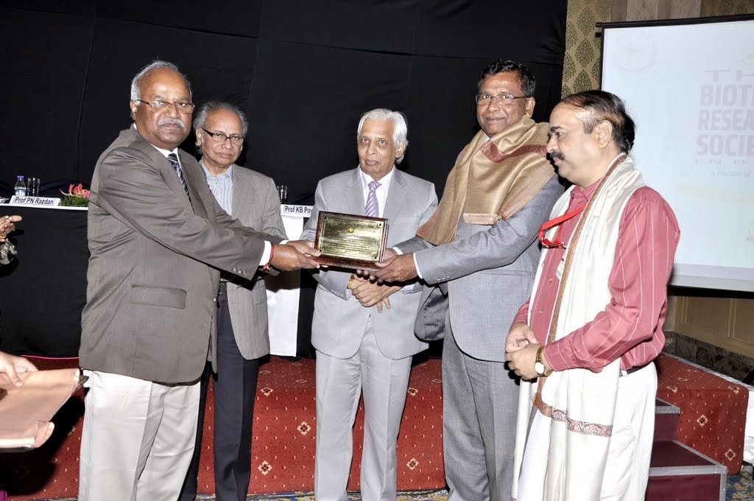
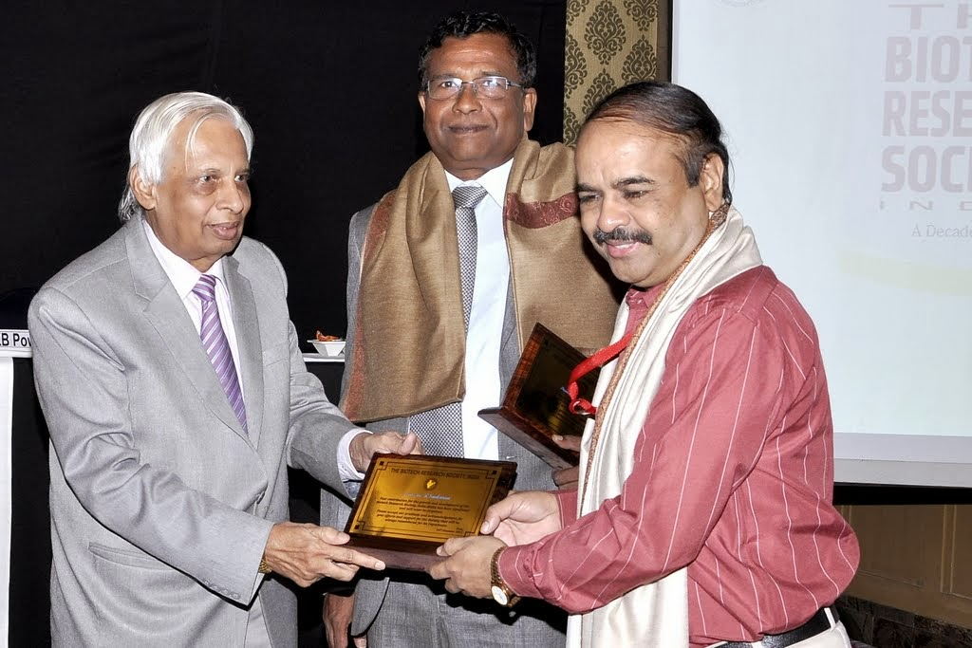

Prof D Madamwar, III Convention (2006), Sardar Patel University, Vallabh Vidyanagar

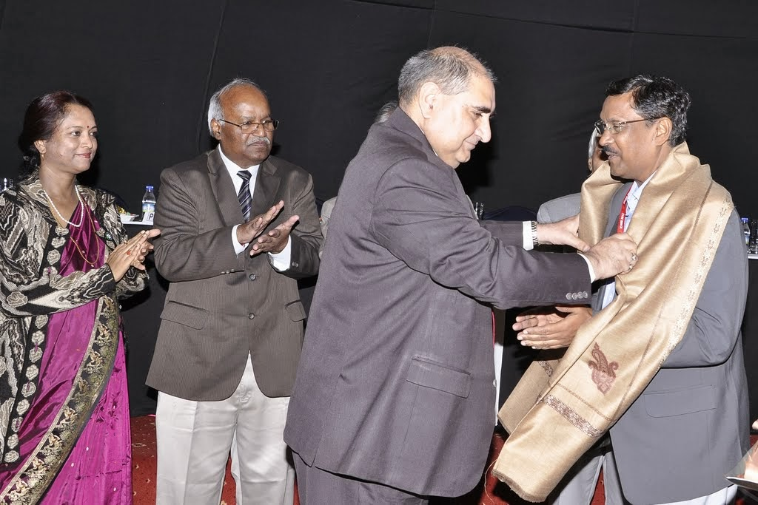

Prof Ashok Pandey, IV Convention (2007), National Institute for Interdisciplinary Science and Technology, Trivandrum

Prof LV Rao, V Convention (2008), Osmania University, Hyderabad

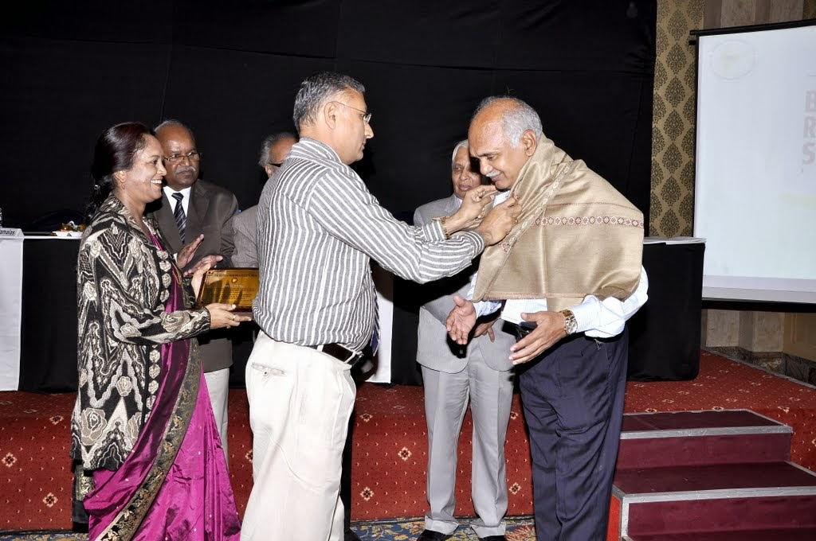
Prof Anil Kumar Tripathi & Prof SN Upadhyay, VI Convention (2009), Banaras Hindu University, Varanasi

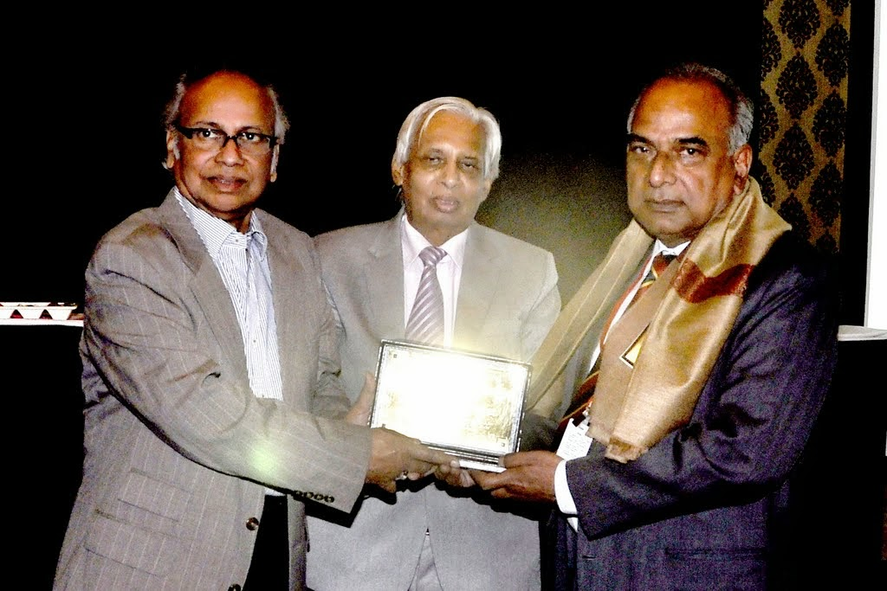

Prof P Gunasekaran, VII Convention (2010), Madurai Kamaraj University, Madurai

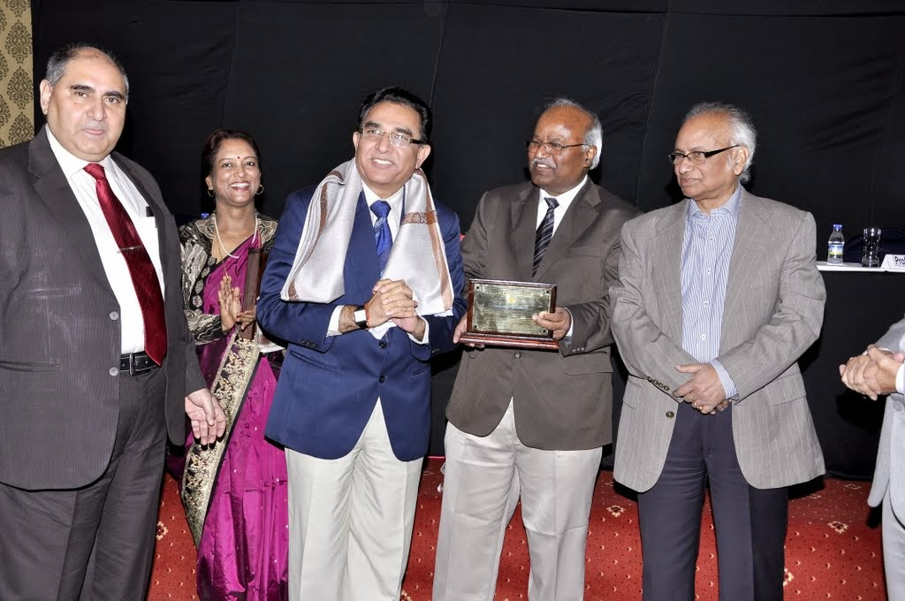

Dr K Madhavan Nampoothiri & Dr Rajeev Kumar Sukumaran, VIII Convention (2011), National Institute for Interdisciplinary Science and Technology, Trivandrum

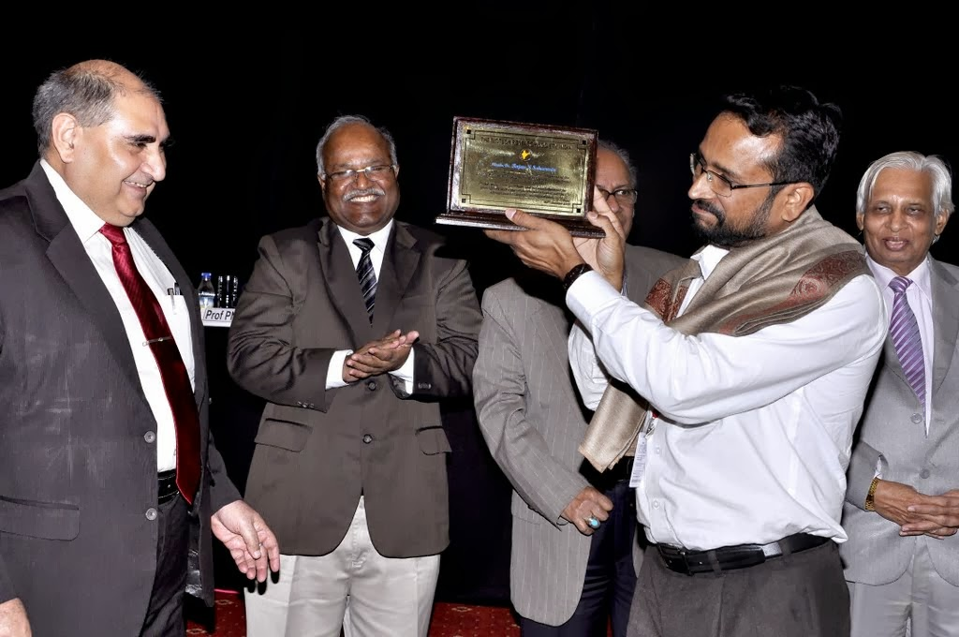
Prof Ram Sarup Singh, IX Convention (2012), Punjabi University, Patiala

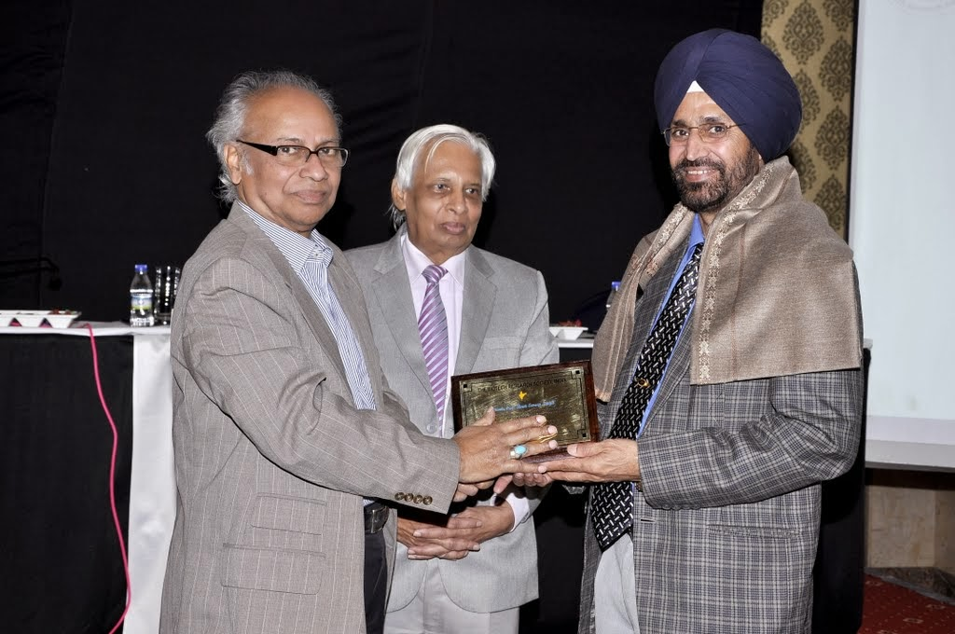

Dr Neelu Nawani and Dr MB Khetmalas, X Convention (2013), Dr DY Patil Institute of Biotechnology & Bioinformatics, Pune.

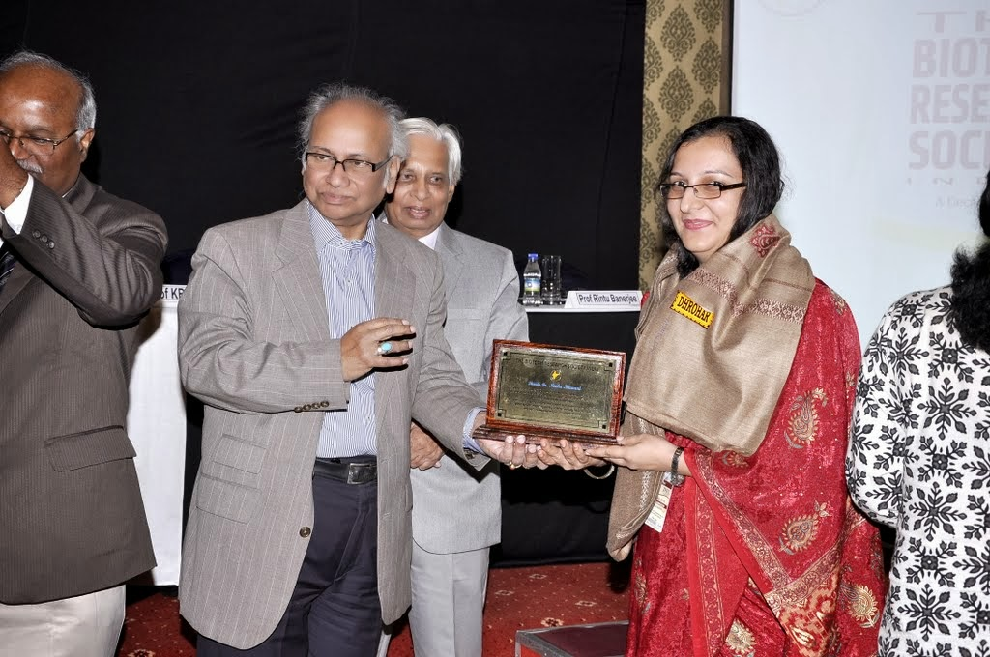

Some of the founder governors who were present on the occasion were also honoured. These included:

Dr RA Pandey, National Environmental Engineering Research Institute, Nagpur

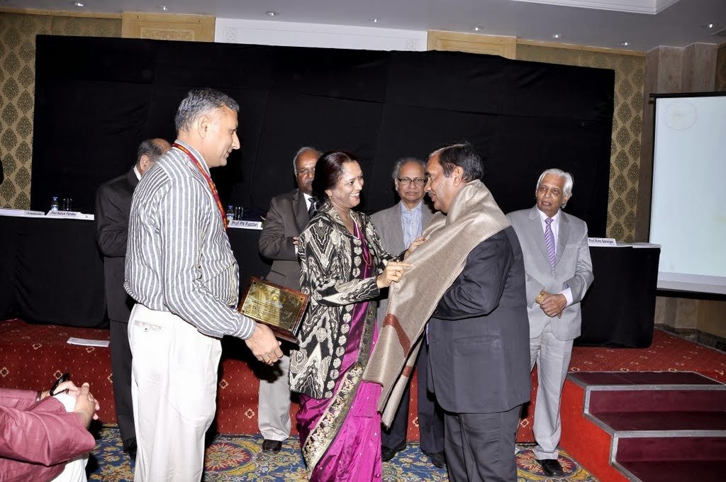
Dr Nagendra Prabhu, SD College, Alleppy

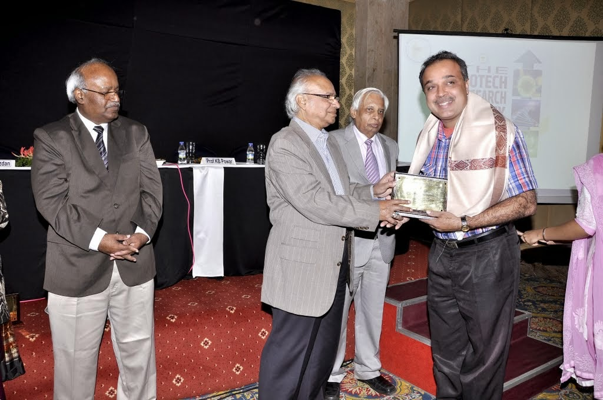

Prof IS Thakur, Jawahar Lal Nehru University, New Delhi

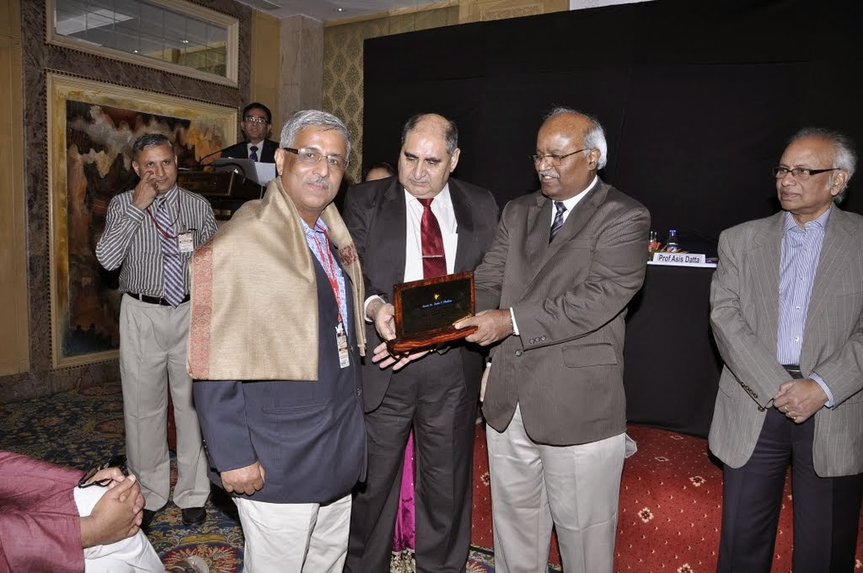

The decennial function came to an end with acknowledgements and gratitude presentation made by Prof R Banerjee, who thanked the dignities on the dais, invitees and members of the Society for their participation in the function. She expressed her thankfulness to all concerned who have directly or indirectly contributed for the growth and development of the Society.

